Alvaro Gonzalez

SDEV 220

Professor Newell

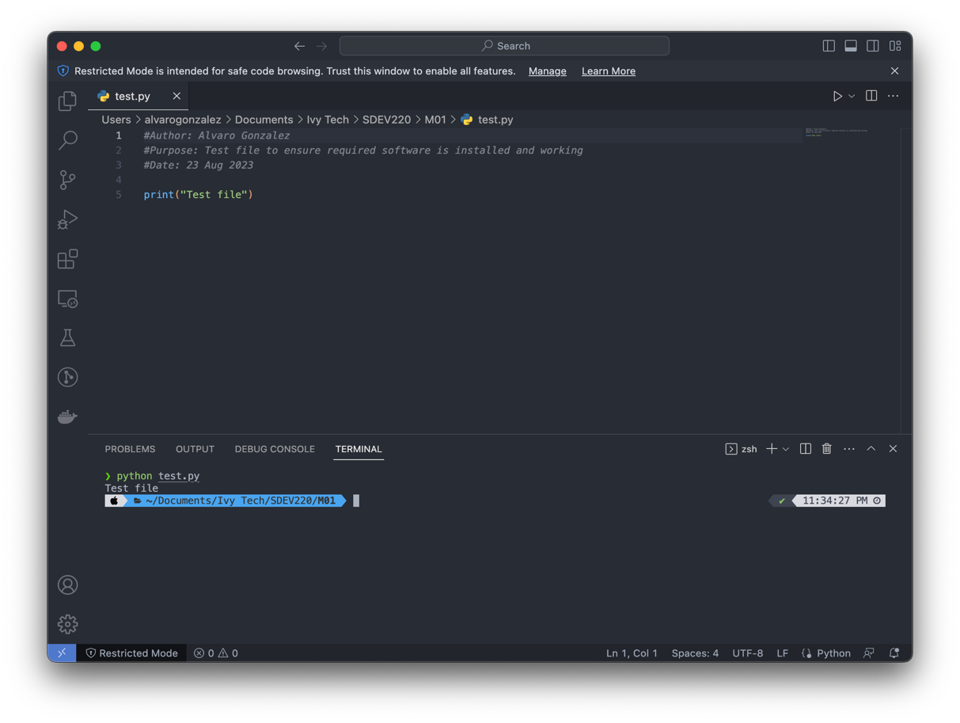M01: Setting Up for Class

1.

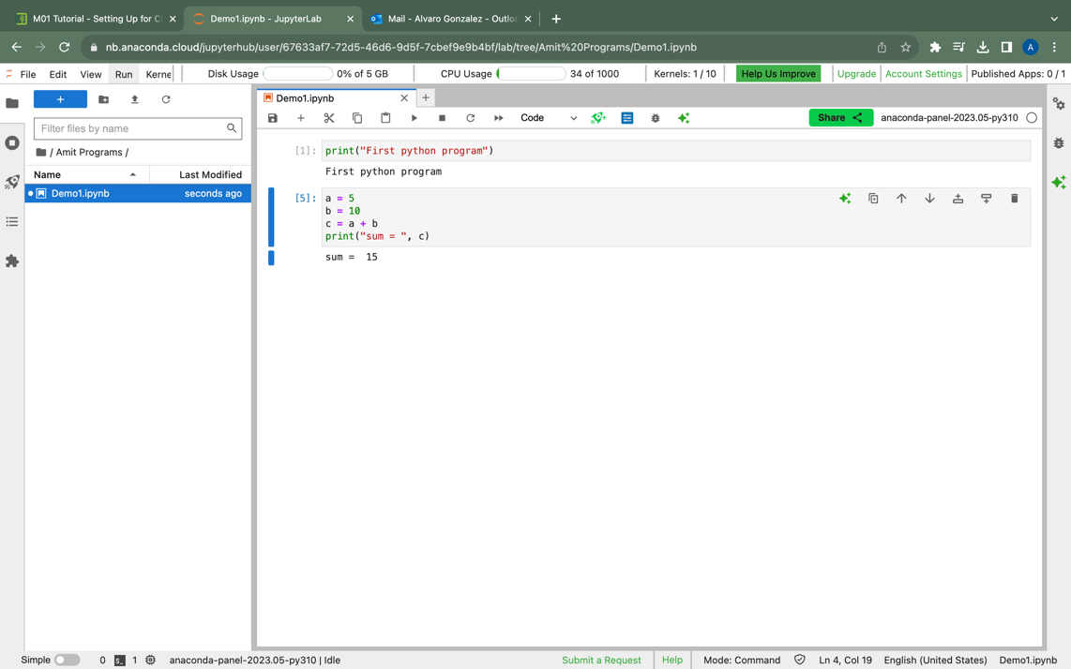

2.